**Pre-Training LLMs – Upstage: Sung Kim and Lucy Park**

**Introduction**

What is pre-training?

Pre-training a Large Language Model is a process of taking a model, generally a transformer neural network, and training it on a large corpus of text using supervised learning, so that it learns to repeatedly predict the next token given an input prompt.

Pre-training = first step of training an LLM before any fine-tuning to have it follow instructions, or further alignment to human preferences is carried out.

What is a base model?

The output of a pretraining is known as a base model, and will cover both training from scratch (meaning from randomly initialized weights), as well as taking a model that is pre-trained and continuing the pre-training process on your own data.

Constrains in pre-training from scratch

Training a LLM from scratch is computationally expensive (a minimum cost of maybe about $1k for the smallest models and up to tens of thousands of dollars to hundreds of thousands of dollars for maybe a billion parameter scale model), requiring multiple state-of-the-art GPUs and training runs that can last weeks or months. For this reason, most developers won’t pretrain a model from scratch. They take an existing model, and either use prompting or use fine-tuning to adapt it to their own tasks.

Situations where pre-training may still be preferred

However, there are still some situations where pre-training a model may be required or preferred.

Upstage: has been doing pre-training for its customers. Some customers are building models for tasks in specific domains like legal, healthcare, and e-commerce. Others need models with stronger abilities in specific languages such as Thai and Japanese.

Depth Upscaling

New training methods are making more efficient pre-training possible, like Depth Upscaling, which uses 2 or more sets of existing models to build larger models. Because of this technological improvement, there are more and more interest in pre-training.

Depth upscaling creates a new, larger model by duplicating layers of a smaller pre-trained model. The new model is then further pre-trained resulting in a better, larger model than the original. Models created in this way can be pre-trained with up to 70% less compute than traditional pre-training, representing a large cost saving.

Is pre-training suitable for you?

Whether pre-training is suitable for your work depends on several factors, such as whether a model might already be available that might work for your task without pre-training, and what data you have available, as well as the compute resources you have access to, both for training and serving. And lastly, the privacy requirements you may have, which may also implicate regulatory compliance requirements.

What will be learnt in this course

In this course, you would learn all of the necessary steps to pre-train a model from scratch, from gathering and preparing training data, to configuring a model and training it. You will:

* Start by looking at some use cases where pre-training a model is the best option to get good performance.
* Discuss the difference between pre-training and fine-tuning.
* Walk through data preparation steps that are required to pre-train a model.
* Explore how to gather data from the internet, or existing repositories like HuggingFace.
* Look at the steps to obtain high quality training data, including deduplication, filtering on the length of text examples, and language cleaning.
* Explore some options for configuring model architecture.
* See how to modify Meta’s Llama models to create larger or smaller models, and then look at a few options for initializing weights, wither randomly or from other models.
* See hoe to train a model using the open source HuggingFace library and actually run a few steps of training to observe how the loss decreases as the training progresses.

This course uses smaller models with just a few million parameters to keep things lightweight enough to run on a CPU, but you will be able to use the code from the lessons to scale to both larger datasets and models, and also to train on GPUs.

**Lesson 1: Why pre-training?**

Explore a few options where pre-training is the best option to get good performance. You will also try generating some text with different versions of the same model to see how the performance differs between a base general model, a fine-tuned model, and a specialized pre-trained model.

Multi-stage Continual Training

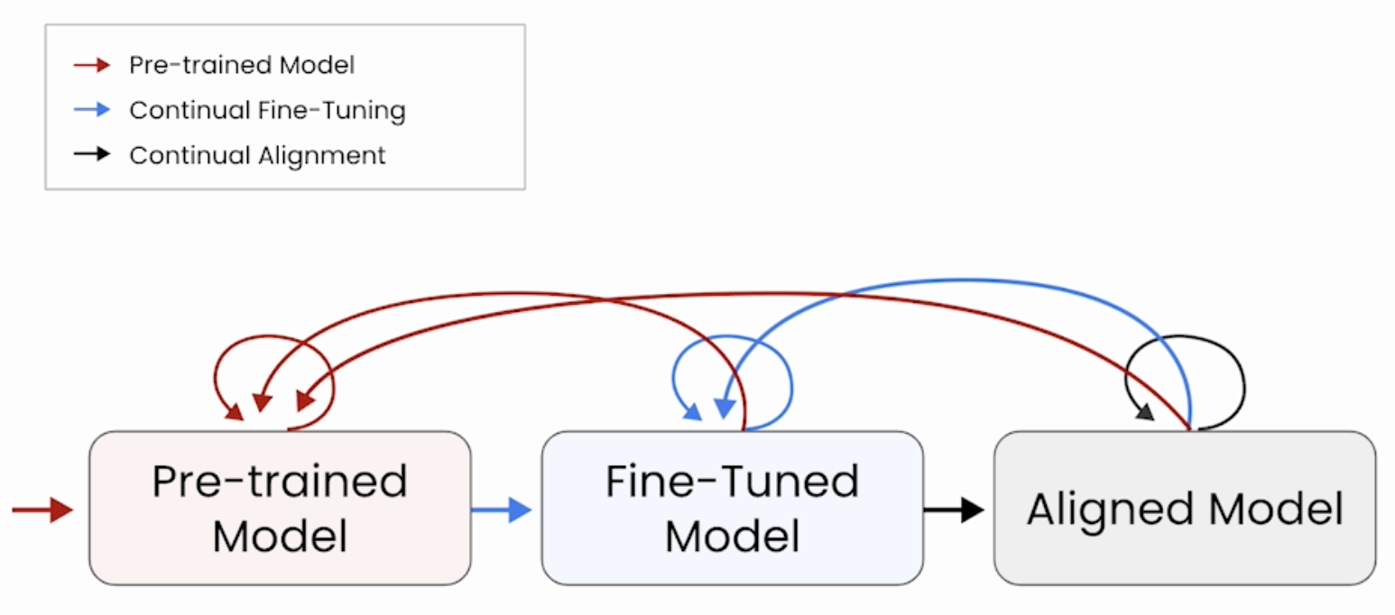

Fine-tuning – Make them better at following instructions

Alignment – Align with human preferences to make them safe and helpful.

The model only has knowledge of the content that was in the training data. So if you want the model to have more knowledge you have to do more training on more data. Additional fine-tuning or alignment training is useful to teach the model a new behavior or avoiding a particular topic.

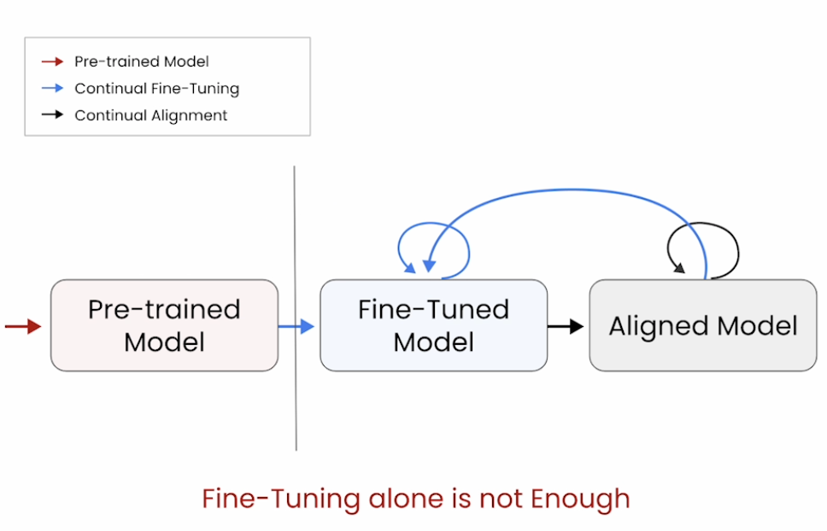

People often try to add new knowledge without pre-training, focusing on fine-tuning the model with smaller datasets. However, this doesn’t work in every situation, especially if the new knowledge is not well represented in the base model. In these cases, additional pre-training is required to get good performance.

Jupyter Notebook here

Price Comparison

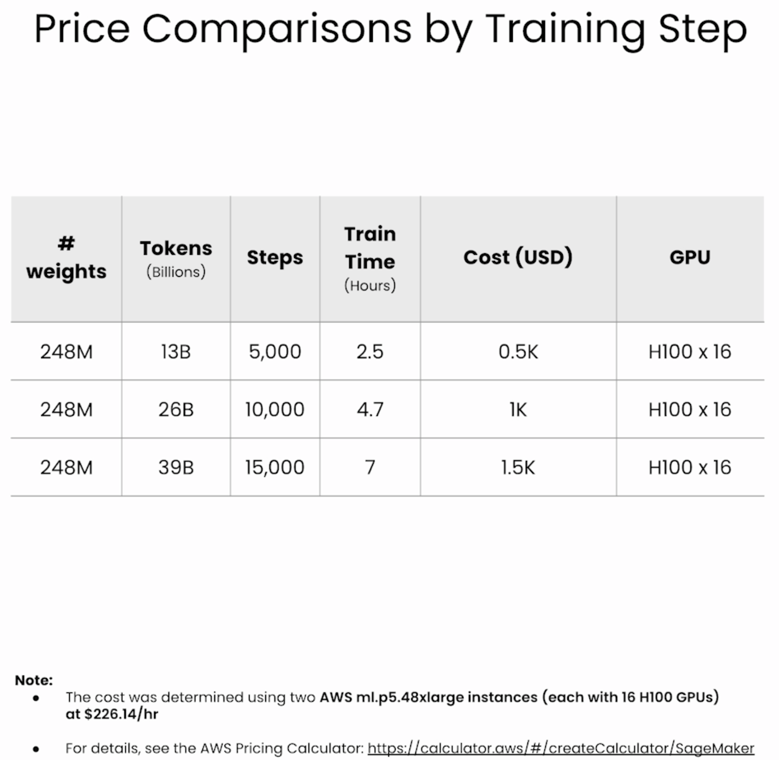

**Lesson 2: Data Preparation**

Data used by Pre-training an Autoregressive text generation model: Vast amount of unstructured text.

Data used in fine-tuning is highly structured (Instruction-response pairs). The goal of fine-tuning is to get the model to behave in a certain way, or to get good at completing a specific task.

Pre-training is like reading many books. Fine-tuning is like a practice exam.

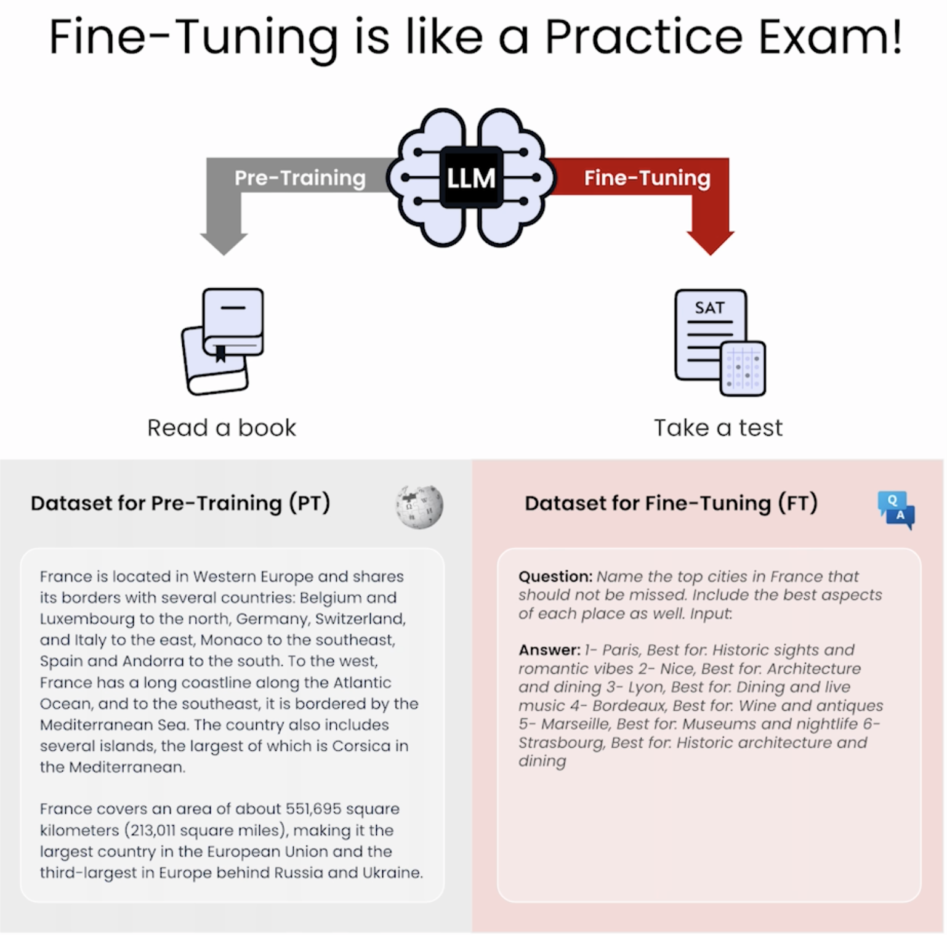

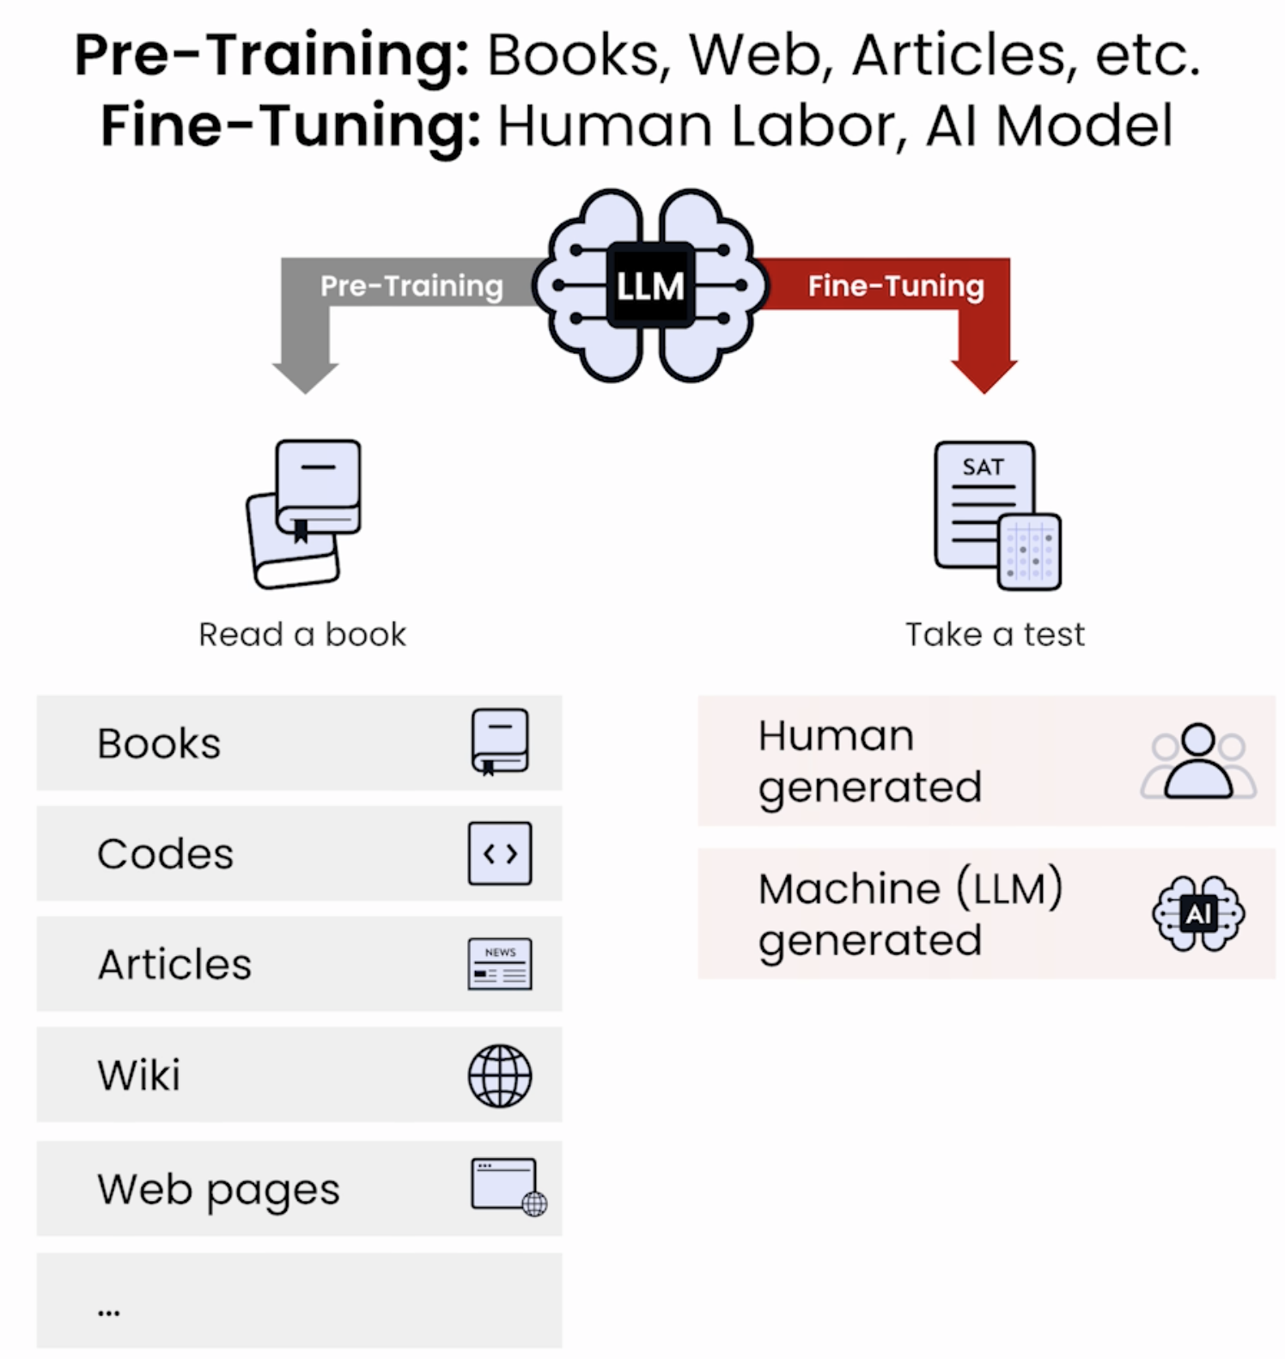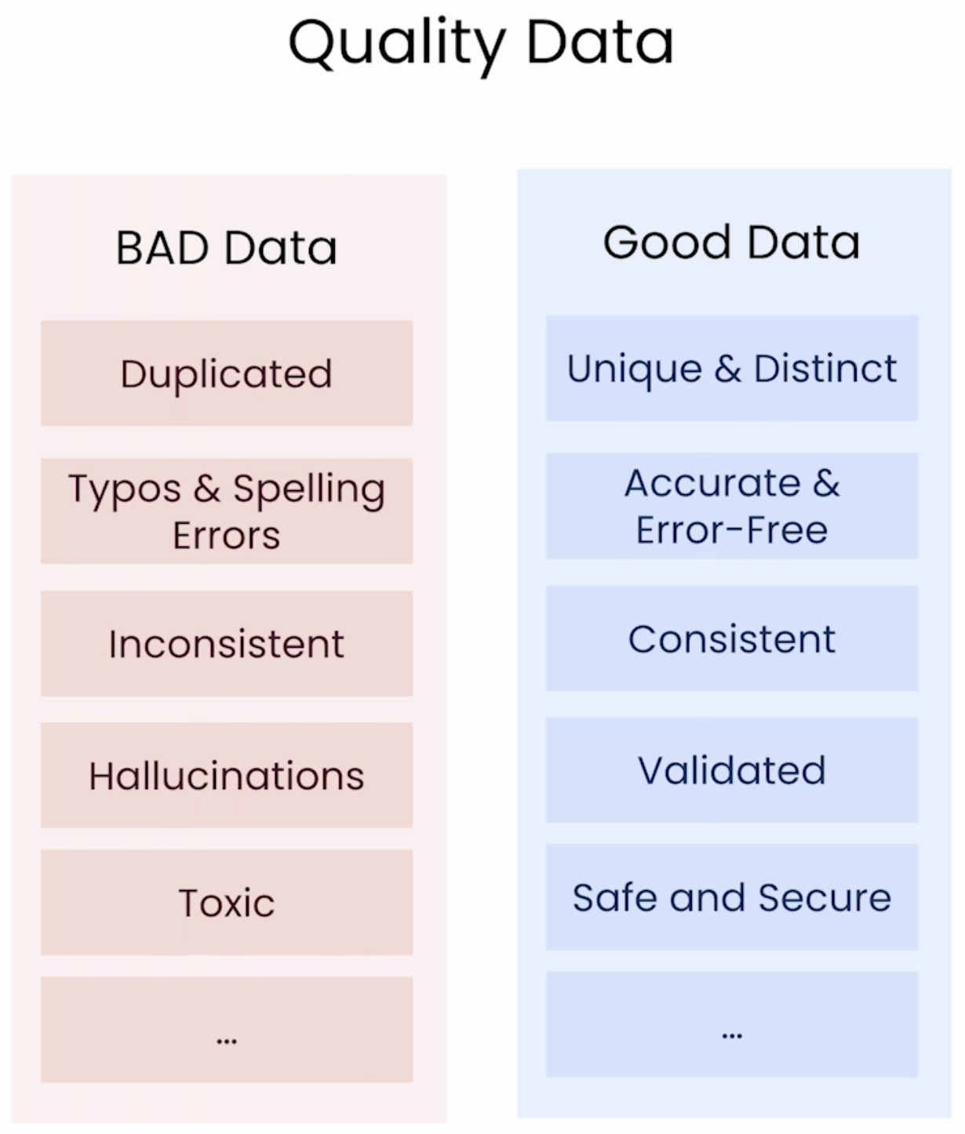

Data Quality is very important in pre-training LLMs. If there are issues with pre-training data, then the resulting LLM would not perform well. Need to ensure that the training data is with high quality.

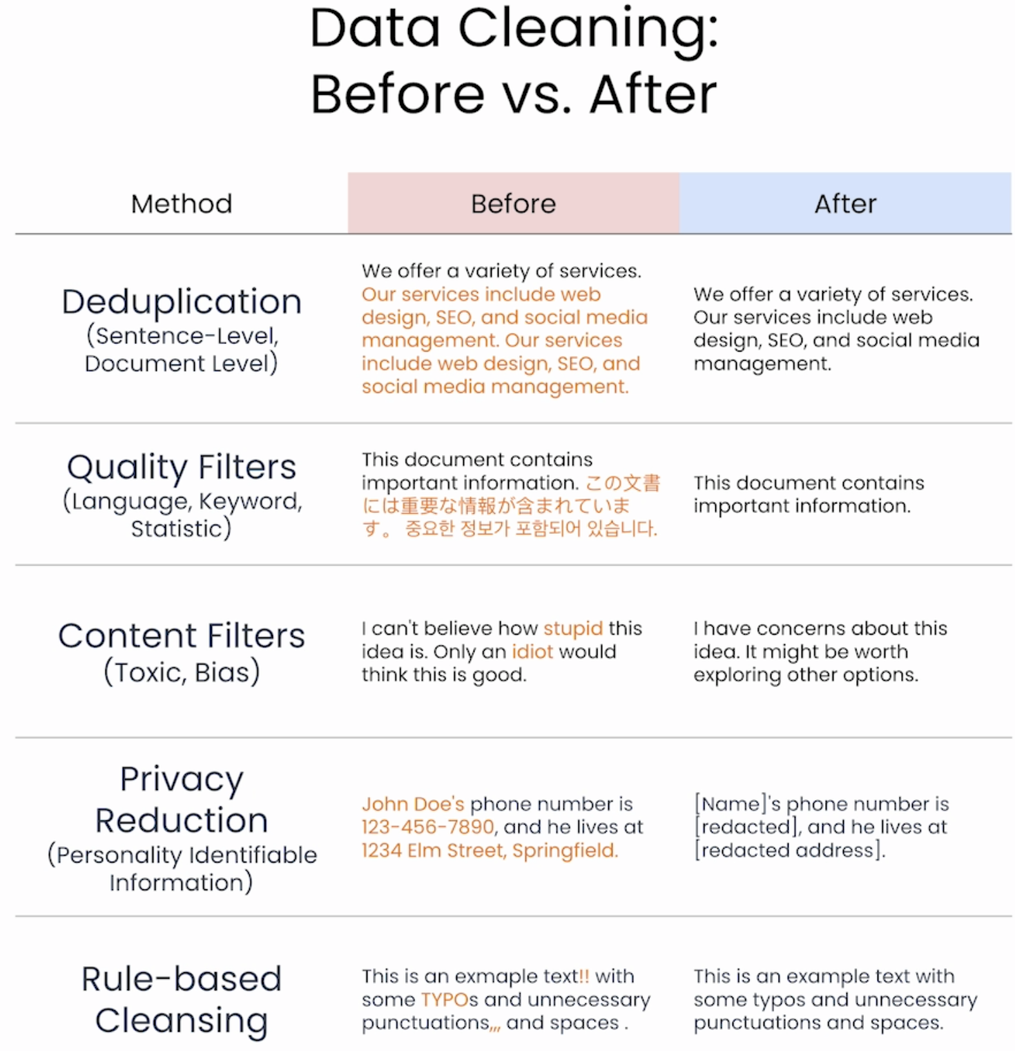

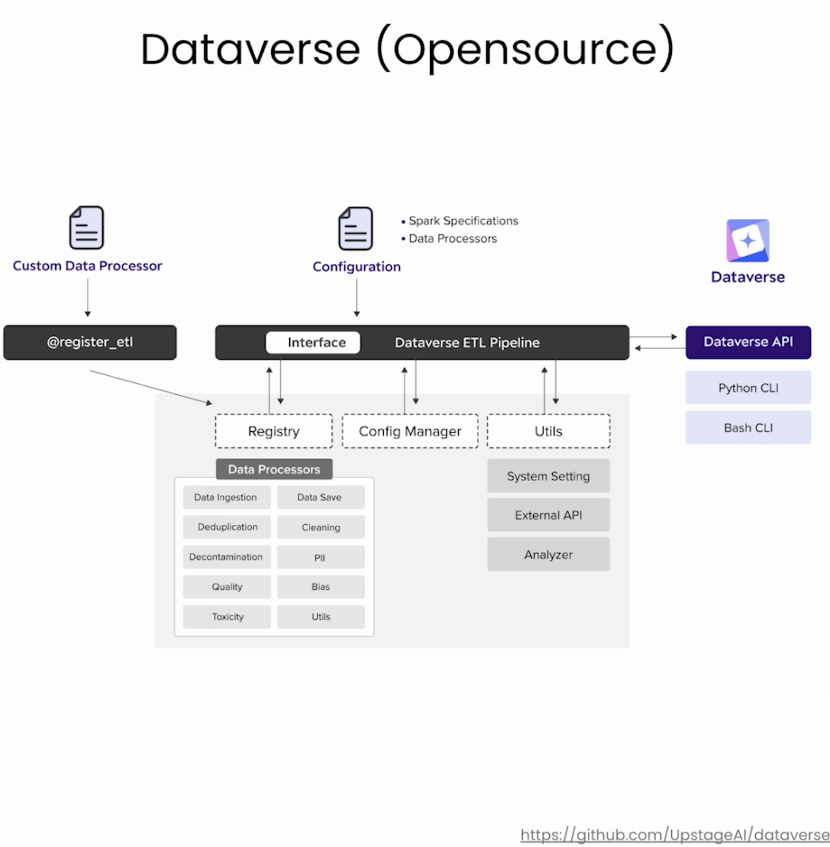

**Lesson 3: Packaging Data for Pretraining**

Need to data manipulation.

Data Packaging: Tokenizing + Packing

Tokenizing: Breaking each text into smaller, meaningful units, which are called tokens.

* Tokenization breaks text into smaller units called tokens (numbers in a list sequence). It depends on the vocabulary and the tokenization algorithm of the model. Each model has a specific tokenizer.

Packing: Packing tokens into the maximum sequence length to improve training efficiency.

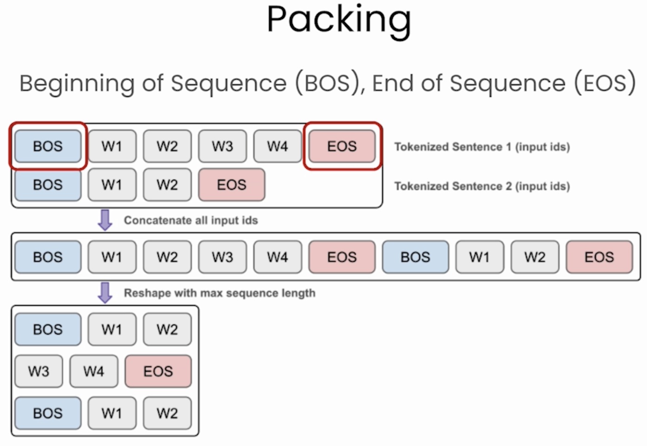

**Lesson 4: Model Initialization**

Model Architecture

Now there is a need for a model to train.

There are several ways to configure and initialize a model for training. And the choice will impact how quickly pre-training proceeds.

Some options:

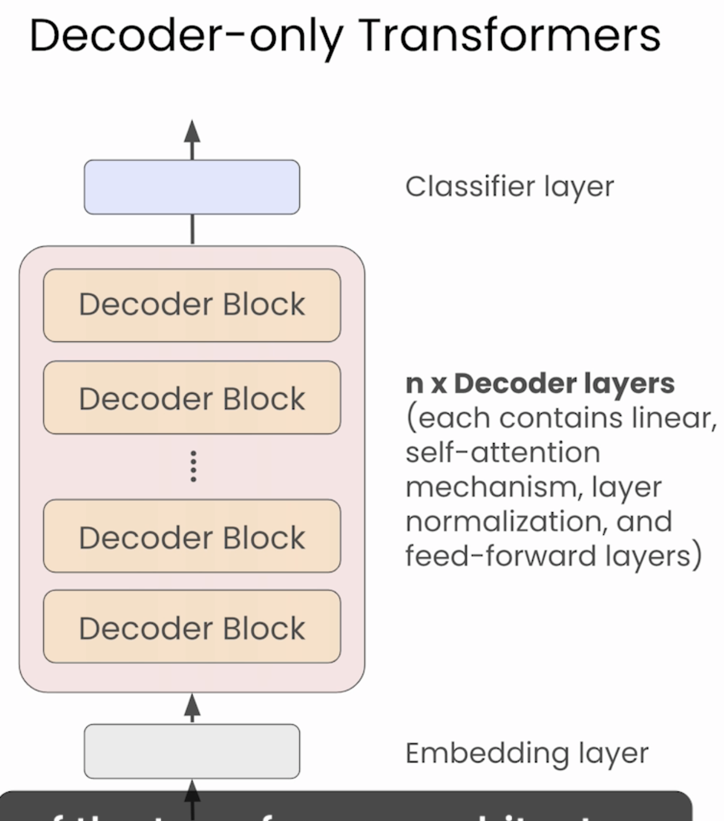

Although there are several variations of the transformer architecture used in LLMs, this course is focusing on decoder only or autoregressive models.

The decoder only architecture simplifies the model and is more efficient for the next token prediction.

OpenAI’s GPT Models and the most other popular LLMs (LLaMa, Mistral, PyCon) are decoder only architecture. Upstage also uses this.

A decoder only architecture is made up of an embedding layer that turns text to vector representations, and then several decoder layers each of which contains several different parts that are based on neural networks. Lastly, the model ends with a classifier layer that predicts the most probable next token from the vocabulary.

Initialize the weights

Once we decide the architecture, the next step is to initialize the weights.

These weights get updated during training as the model learns to predict the next token from the examples in the training data.

There are a few ways that you can initialize the weights.

* The simplest choice is to initialize the weights with random values. -> This means that training takes a long time and requires a huge amount of data.

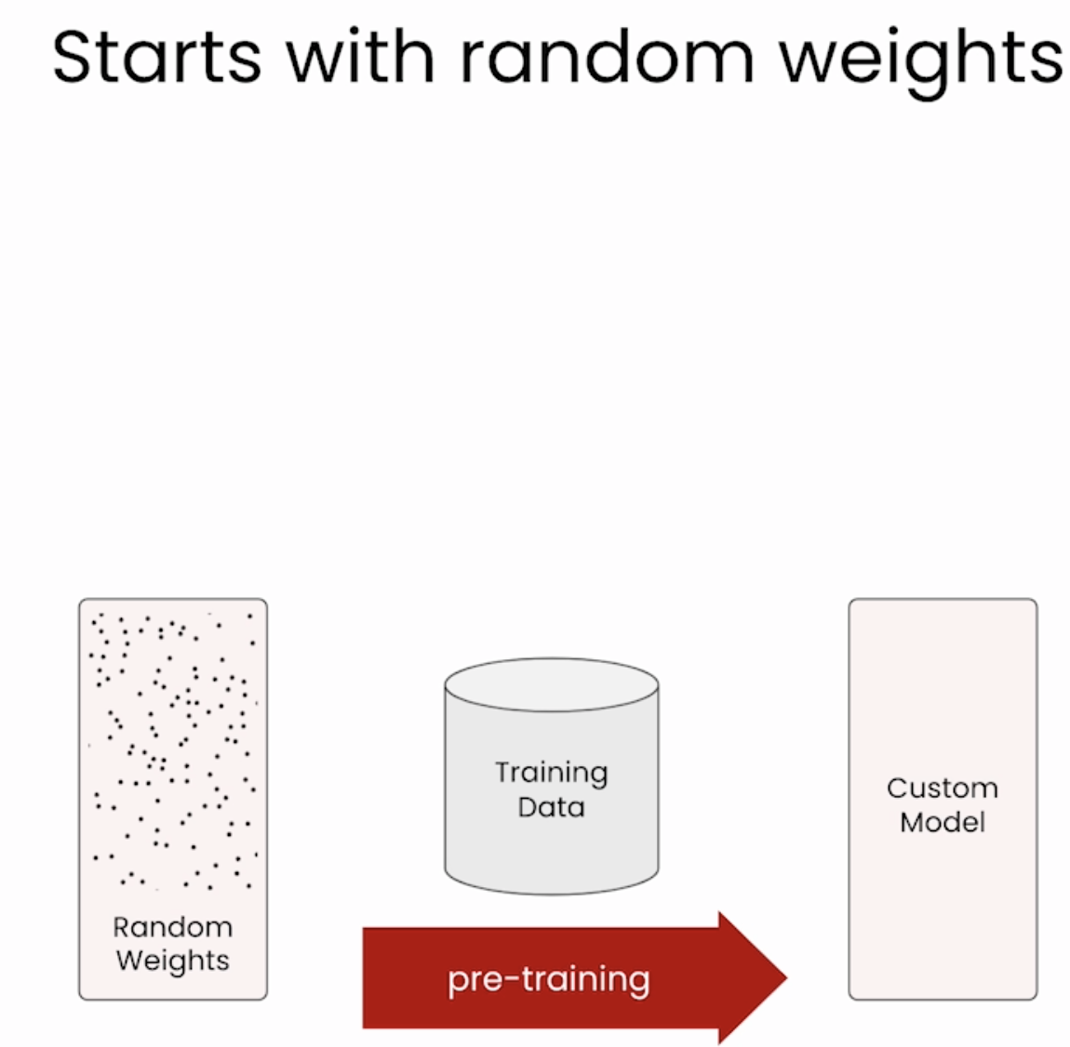 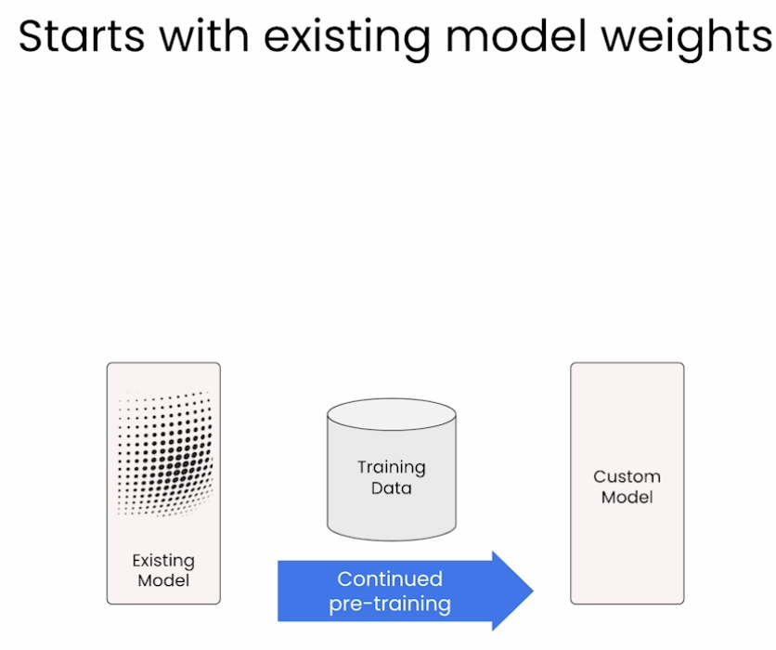

* A better way is to reuse existing weights. For example, if you want to train a 7B model, you can start from Llama 7B or Mistral 7B weights. -> This means that your model has already been trained and get some basic knowledge, so you can generate texts very well already. This is the best way to start if you want to continue on new domain data. Training in this scenario generally takes much less data and time than starting from random weights. With all the models available in the world right now, this can be a great option for creating your own custom LLM.

Model Scaling

Model Scaling removes or adds layers to an existing model, and then carries out more training, to create a new model with a different size.

Downscaling

If you want to make a smaller model, down scaling can be used. Downscaling involves removing layers to produce a smaller model than the one you start with. This approach can work well for large models, but it doesn’t work well for small models.

In general, layers near to the middle of the models are removed, and then the resulting smaller model is pre-trained on a large part of the text to bring its weights back into coherence.

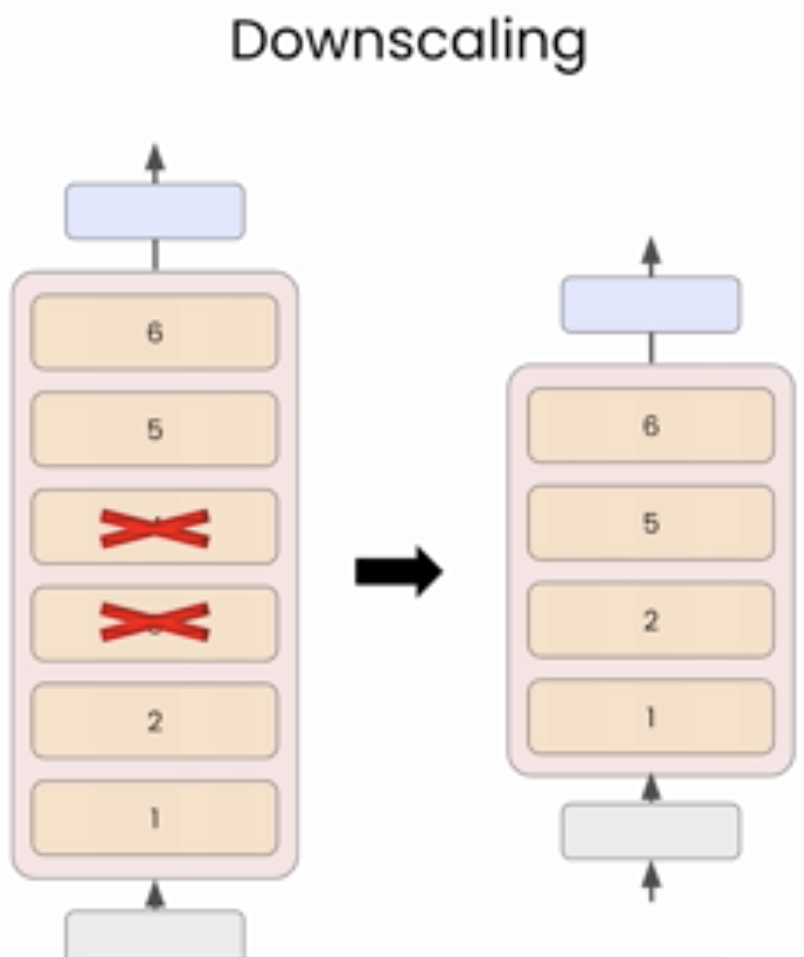

Upscaling

The better method is called upscaling. Start with a smaller model, then duplicate some layers to make a larger model.

Example: To make a 10B model with upscaling, can start with a 7B model. For illustration purpose, assuming 7B model has 32 layers, you can make 2 copies of the model, then use some top layers from 1 copy and some bottom layers from the second copy and put them together to create a new model with 48 layers.

At this point, the model is no longer coherent, inference will not work well, continue the pre-training is required to bring the model back into coherence and enable text generation.

However, because the model weights of the capital layers have already encoded some language understanding and knowledge, it takes less data and time to create a good model.

In fact, upscaling can allow you to train a larger, well-performing model with 70% less data than training the equivalent model from scratch.

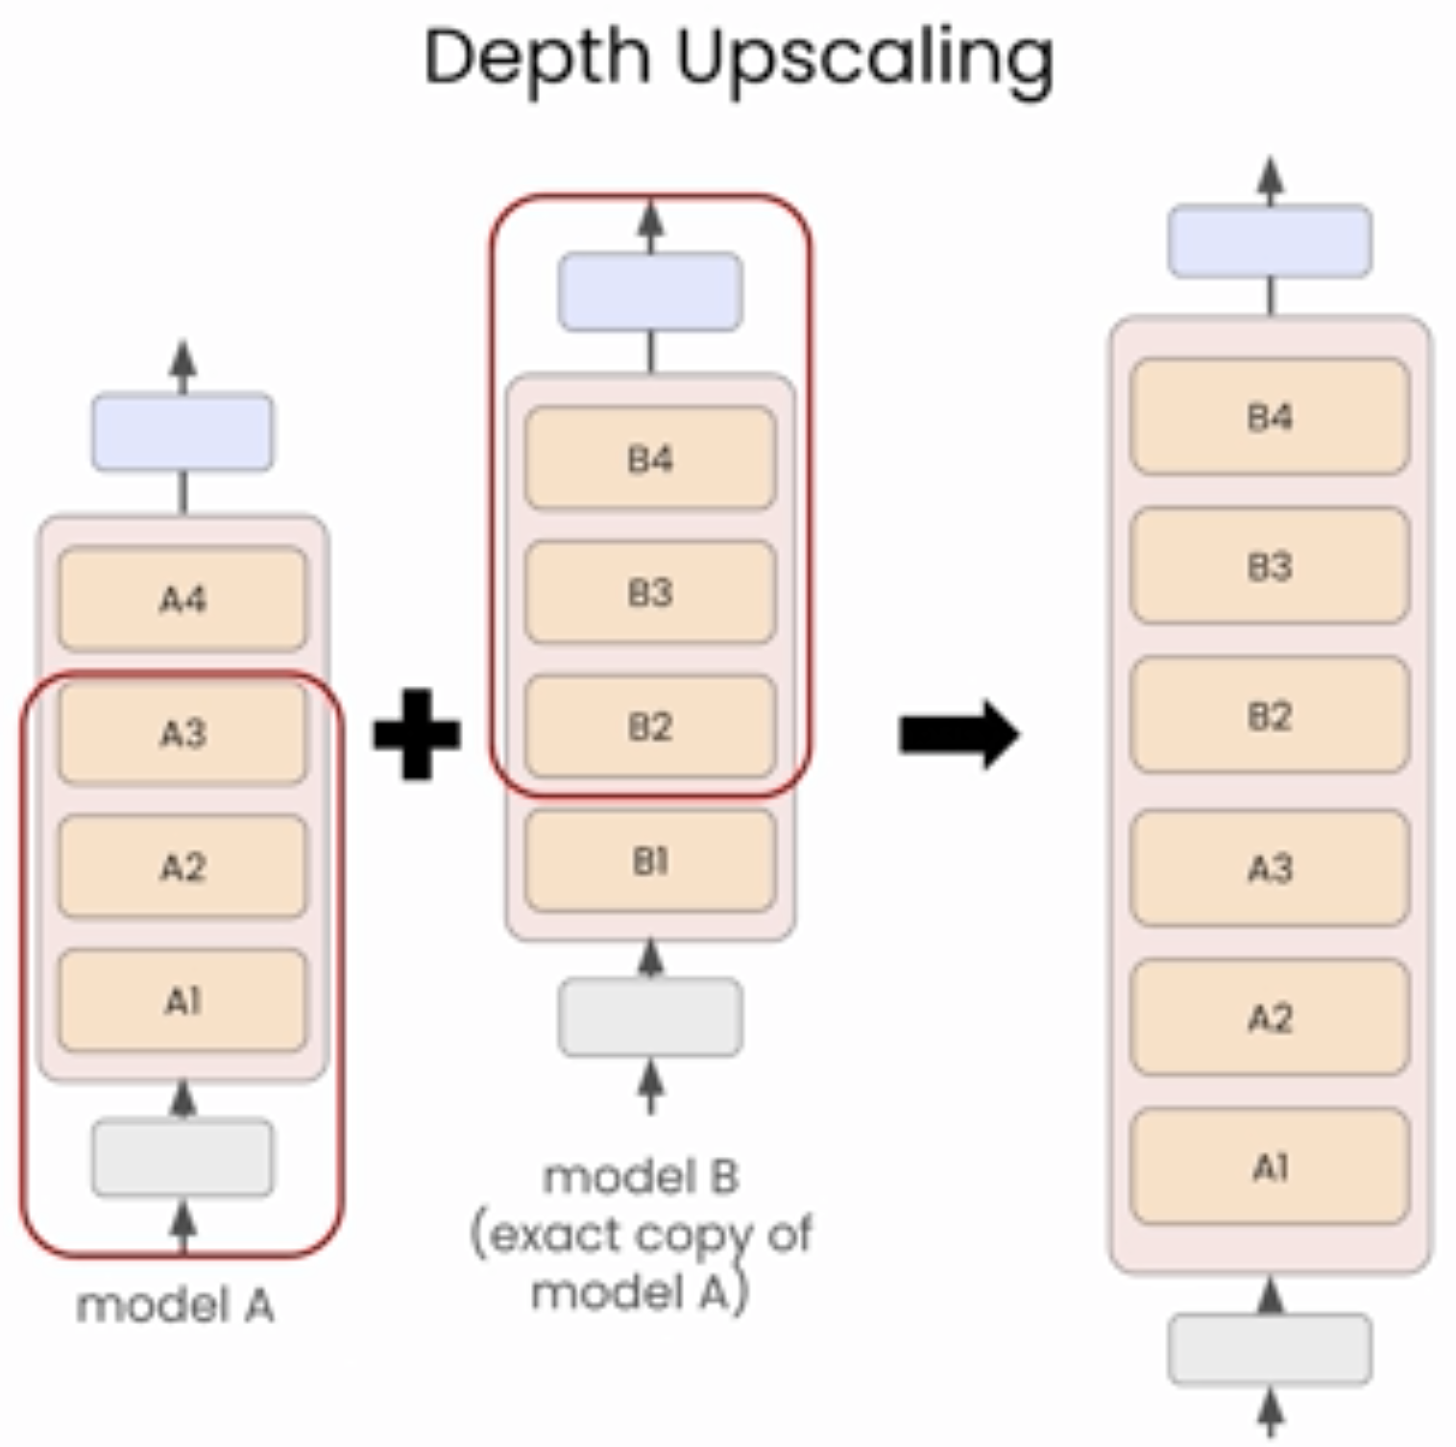

**Lesson 5: Training in Action**

Model Training

Now we are going to train model using HuggingFace Trainer.

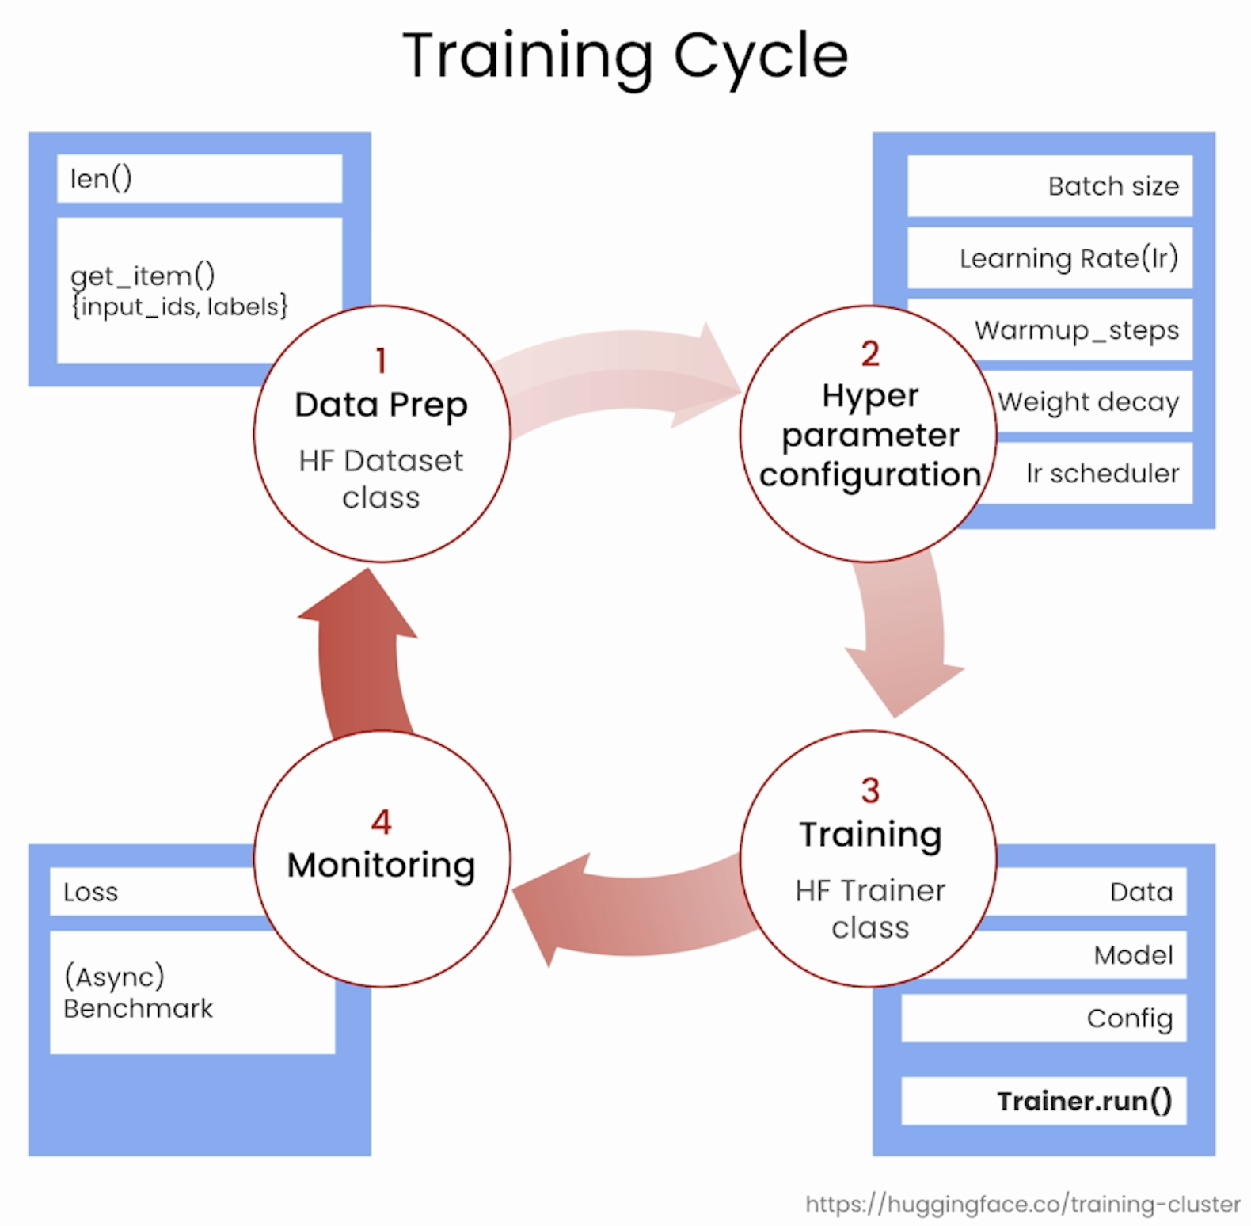

Need to be patient. Training takes a long time (from weeks to months), depends on the hardware.

One important thing to note is that you need more memory for training models than you do for inference. The extra memory is needed to store the gradients and then activations that get updated during the training process.

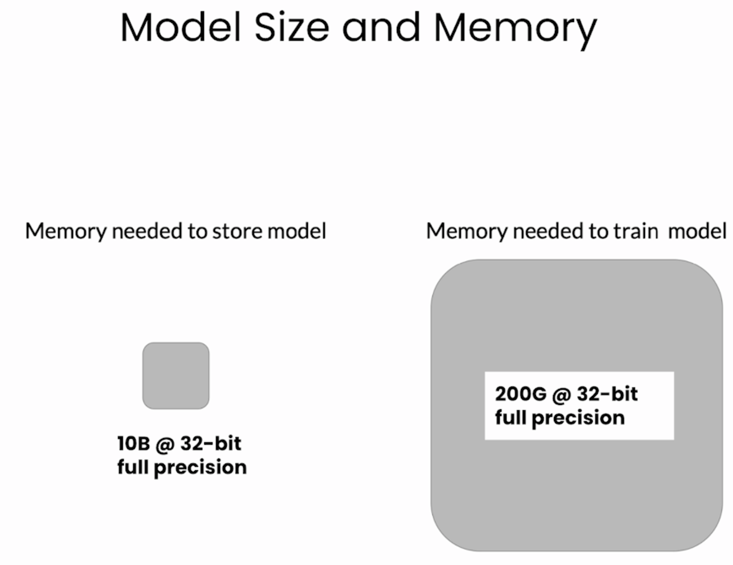

Let’s say you need 10B to store the model, then you actually need up to 20 times, which is 200G of memory for training. This requires multiple GPUs and it is going to be very expensive.

There are calculators you can use to check how much the training job might cost before get started. (Hugging Face Training Calculator).

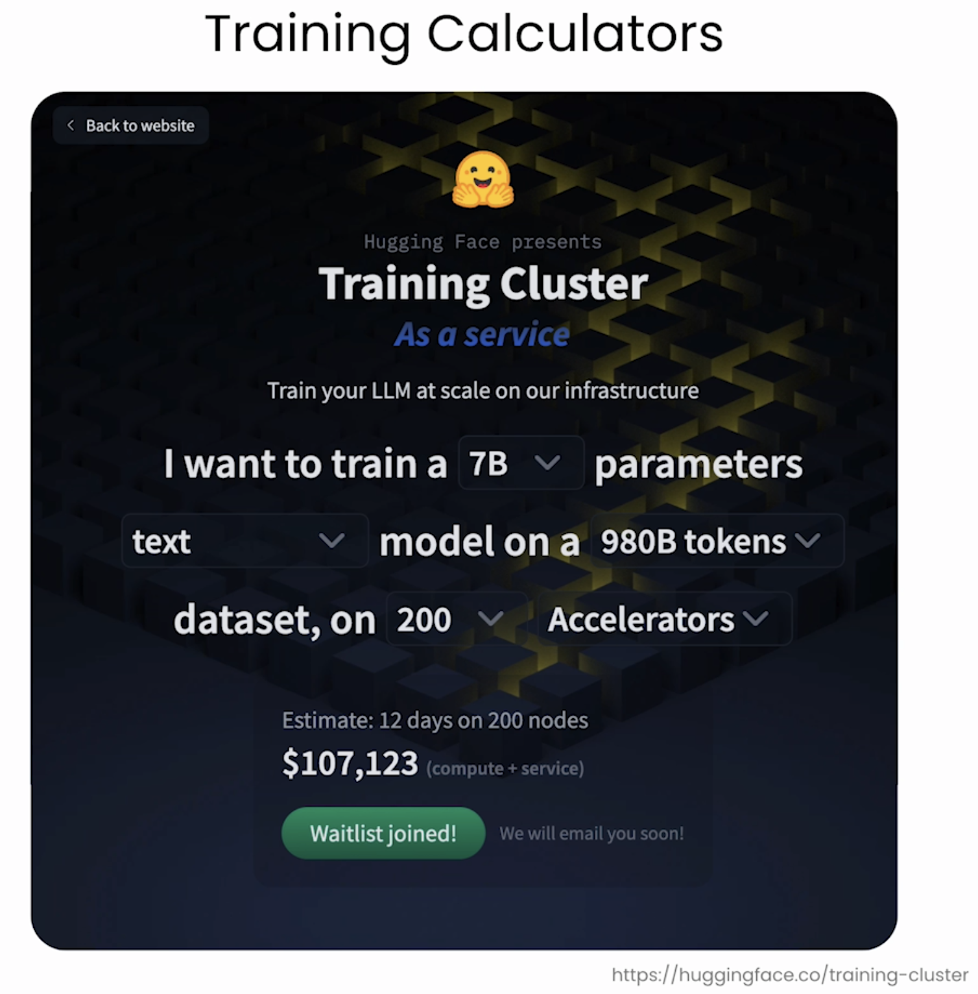

**Lesson 6: Evaluation**

Once finished the pre-training, how do you know how good the model is.

Some of the common evaluation strategies for LLMs, including some important benchmark tasks that are being used to compare the performance of different models.

To evaluate the model, there are 4 evaluation methods:

1. Taking the loss.
2. See the results
3. Compare the models
4. Using benchmark datasets

These are not one-time efforts, but a more continual process.

First Method: Overdriving the loss during the training

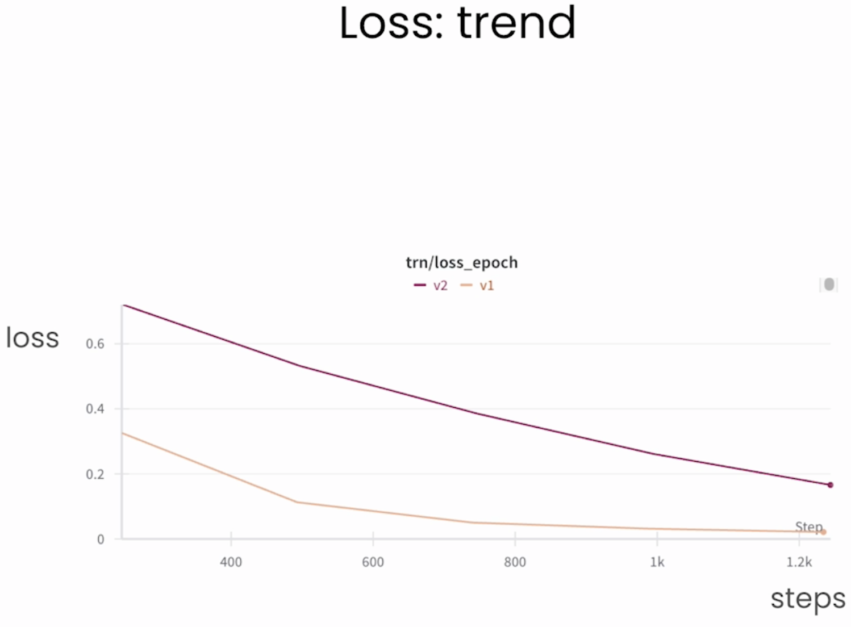

If training is going well, it should be decreasing over time in a consistent way. If it’s not, you might need to reconsider the training hyperparameters, especially the learning rates. You might also want to reconsider your model architecture.

If you observe a flattening of the loss curve, also known as a situation, there could be a few problems.

* One is that the model has reached its maximum learning capacity and cannot learn more from additional data. This could happen when training a small size data. It could also indicate a problem with your training dataset, like a low-quality examples. So need to check the data if you are training a big model and see the situation.

Second Method: See for yourself

When training the LLM, checking the outputs of the model yourself during training is important. So, you can create checkpoints of the models periodically, say every 10000 training steps. Then make sure the model output is what you expect. It should be getting better at generating text over time. Human evaluation is still really important for LLMs, so don’t overlook this step.

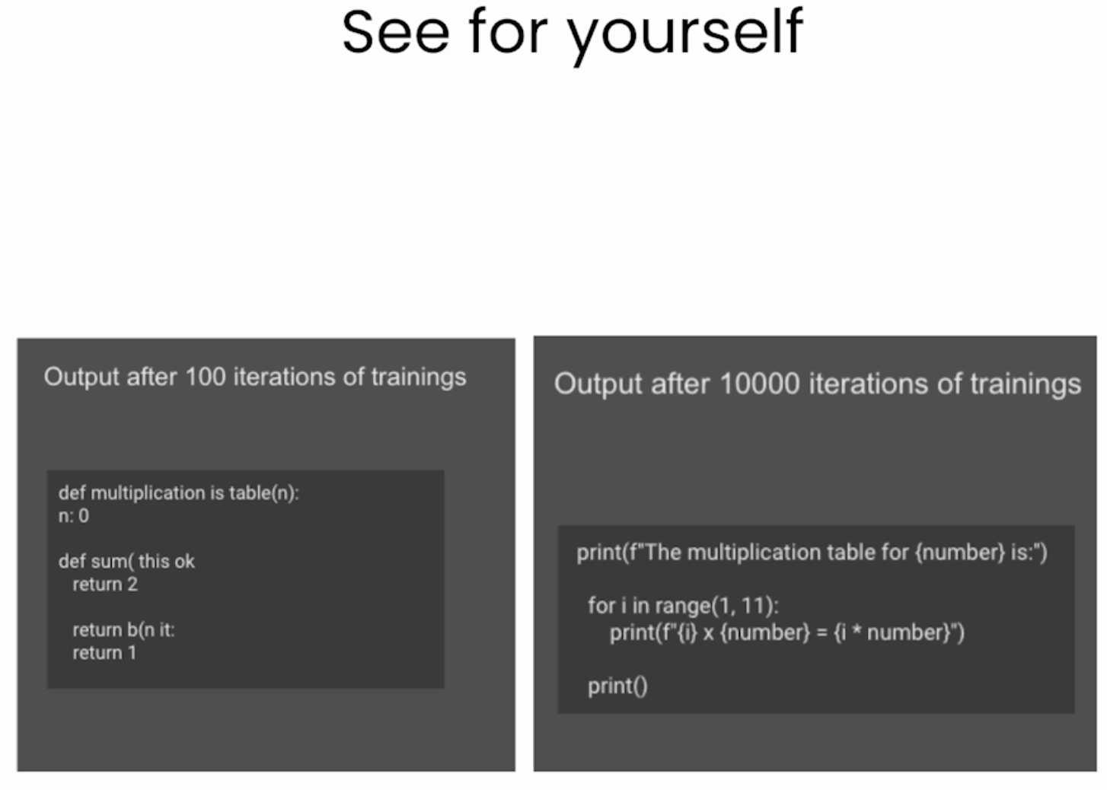

Third Method: Compare with other models

Comparison with other models can also be very useful. When you have 2 results side by side, it is much easier to tell which one is better.

There are some online tools available to compare models, include Upstage Console and an LMC from Berkeley.

This is one of the best ways to benchmark for performance, but it does require human effort.

One active area of research is using an LLM judge to decide which model output is better. But that can be biased depending on how the judge model was trained.

Fourth Method: Benchmark Datasets

The most common evaluation method is to use benchmark datasets. This is like having the LLM take a standardized exams. By testing all models on the same benchmarks, you can get a fair comparison of the abilities and performance of different models.

Some useful benchmarks are as below.   
But depending on how you want to use LLM, it may be more useful to measure compositional abilities.

Ultimately, when evaluating the performance LLM, you have to make a decision that is the best for your model and use cases.

